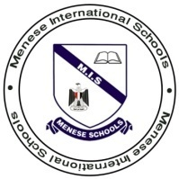
Pedro Puts On A Play
Menese International Schools
Language Arts Grade 4
Vocabulary

Culinary
Related to cooking
- Egyptian’s culinary tradition is Koshary.

Downcast
Sad
I am always a little downcast on rainy days.

Consternation
Very worried
- His decision caused consternation among his colleagues.

Vivid
Bright
- The door was painted a vivid yellow.

Extensive
Big – Huge
- The wind caused extensive damage.

Serenely
Peacefully
- He acted serenely towards bad news.

Reminiscent
Brings back memories.
- A winter day that was oddly reminiscent of summer in its cheering sunniness.

Pensive
Deep Thinking
- Rainy days often put me in a pensive mood.

Recruit
Hire
- We need to recruit more teachers in the school.
Commenced
Began
- The academic year starts at the beginning of October.

