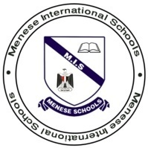
Menese International Schools
Language Arts Grade 4
Vocabulary Lesson 2

Table Tennis Shake-Up

Glared
Stared (look angrily)
- The teacher glared at him as he walked in late.

Legendary
Great and Famous
- AlManasa is the resting place of the legendary Anwar Elsadat.

Muttered
Whispered to oneself
- He sat there shaking his head and muttering to himself.

Gaped
Looked with open mouth
- The children gaped at the monkeys.

Flinched
Move away
- He flinched when I tapped him on the shoulder.

Fluke
Coincidence - Chance
- I got the job by a fluke.

Snickering
Laughing quietly
- We all snickered at her.

Stunned
Shocked
- When they told me she had gone missing, I was totally stunned.

